Websites to search

Mdn – w3school – CSS3pattern Gallary(to linear-gradient)

HTML

* <!DOCTYPE html> (to know version of html)
* <base href = “images/”> (بتتكتب فى الهيد بتبقى عامله ذى الاختصار يعنى كده هكتب فى السورس بتاع الامدج اللينك علط طول من غير اسم الفايل)
* <meta name=”author or descroption” content=””>
* <font size=”(1:7)” color=”” face=”name of fonts”> </font>
* <b> to bold, <I> to italic, <pre>, <br/> self-close, <hr>, <center>, <div>, <span>, <p>, <ul type=”” start=””>, <li>, <ol type=”” start=”” >, <dt> definition list, <dd>, <img src=”” width=”” height=”” alt=”” align=”” >, <textarea cols=”” rows=”” name=””>,
* <select size=”3(عدد اللى هيظهر)” multiple(يعنى اقدر اختار تاكتر من قيمه بكنترول الت)>
  + <option>
* <map>
* <iframe width=”” height=”” scrolling=”no” src=”” frameborder=”” allow=”autoplay” allowfullscreen>
  + (لو عايزه احيب فيديو من على اليوتيوب او خريطه بروح عند الشير واختار ايمبيد وانسخهم)
* <Table width=”” border=”” cellpadding=”” cellspacing=”” >
  + <Caption>, <thead> <th rowspan=”” colspan=”” width=”” bgcolor=””> bolder than <td>, <tbody> <tr> to many row<td>, <tfoot>
* <Form method=”” action=”ا لصفحه اللى هروحلها”>
* Input
  + Type
    - Text, password, hidden, checkbox, radio (بديهم نفس النيم), button, submit, reset, image(type=”image” src=””), file
  + <input type=”” id=”” name=”” value=””>
* <body>
  + Link=”green” , alink=”yellow” (active link) , vlink=”red”
* <a>

[Your Recording 26.wav](https://fcihelwanedu-my.sharepoint.com/personal/amira_20210185_fci_helwan_edu_eg/Documents/Transcribed%20Files/Your%20Recording%2026.wav)

* + Href = “#abc”
  + Name=”abc”
  + <a href=”test/page2.html#tset”> acnhor
  + <a href = “mailto: dhgfj@gmail.com?subject=aaaaa&body=bbbb “> to reach email

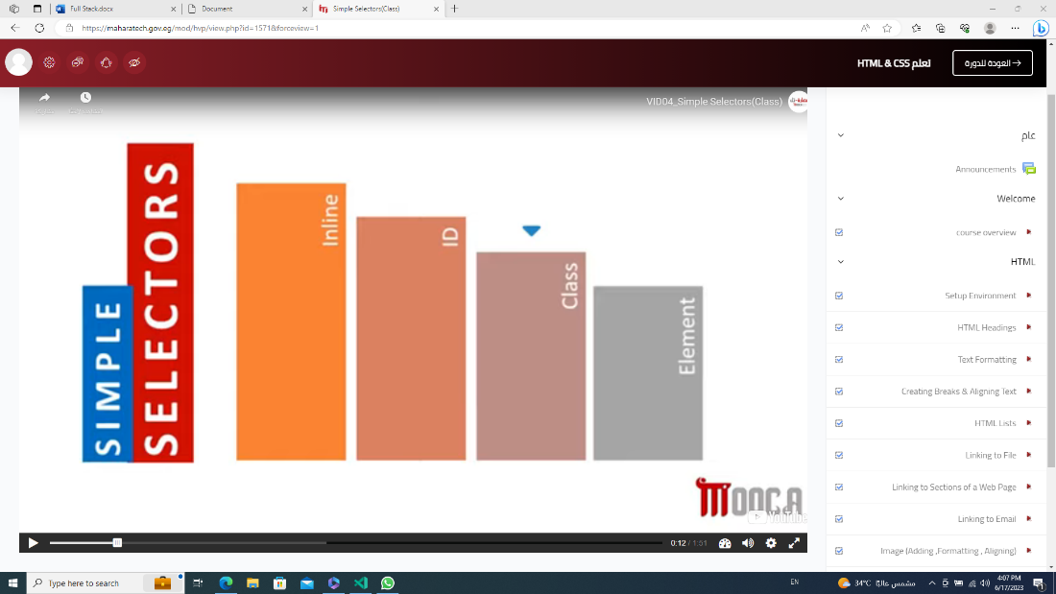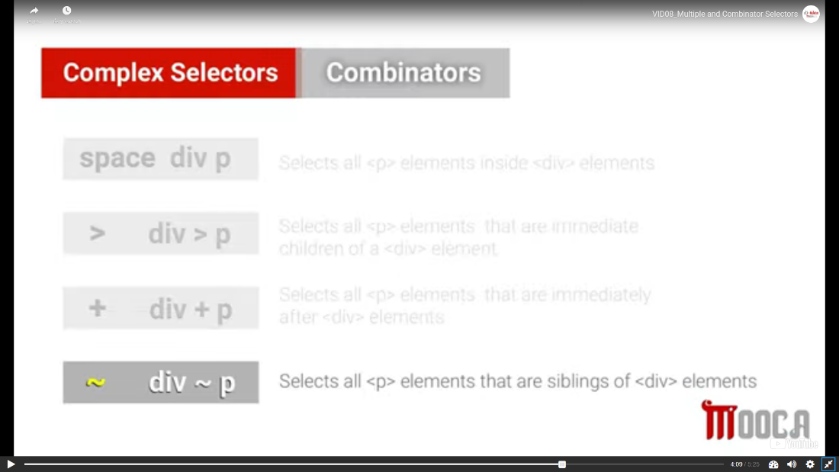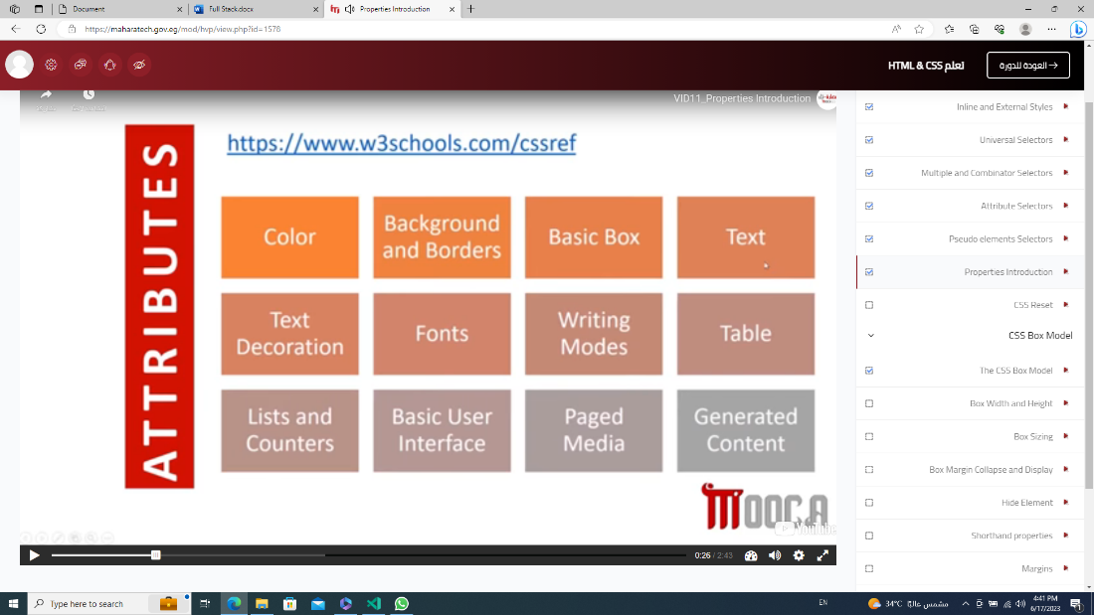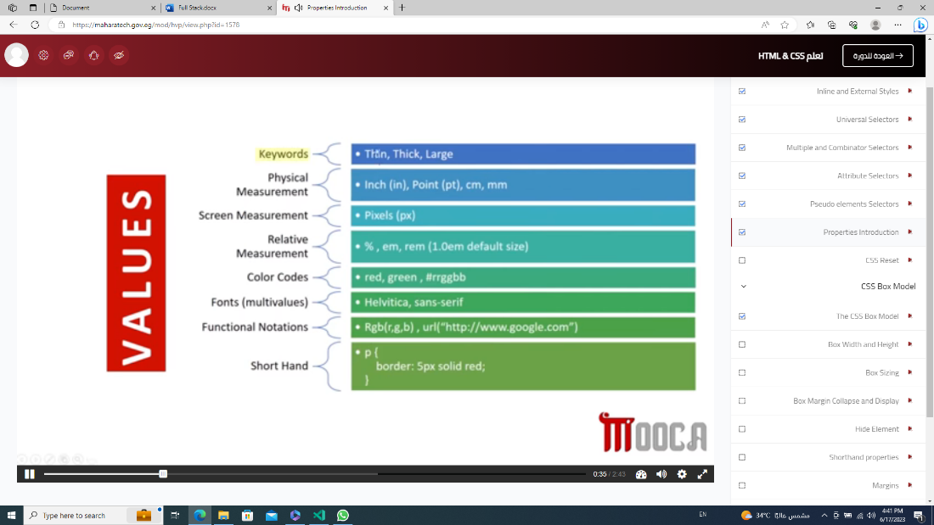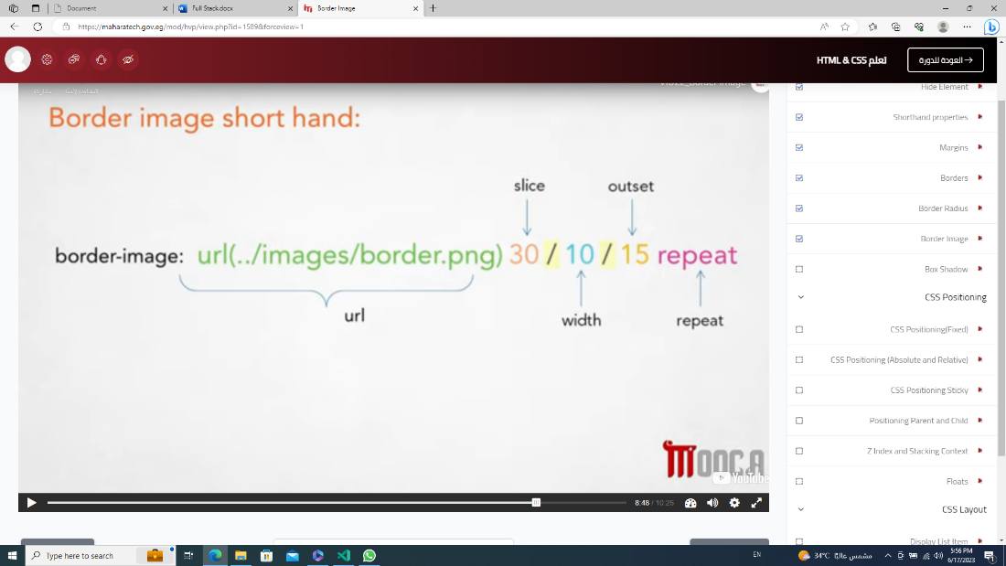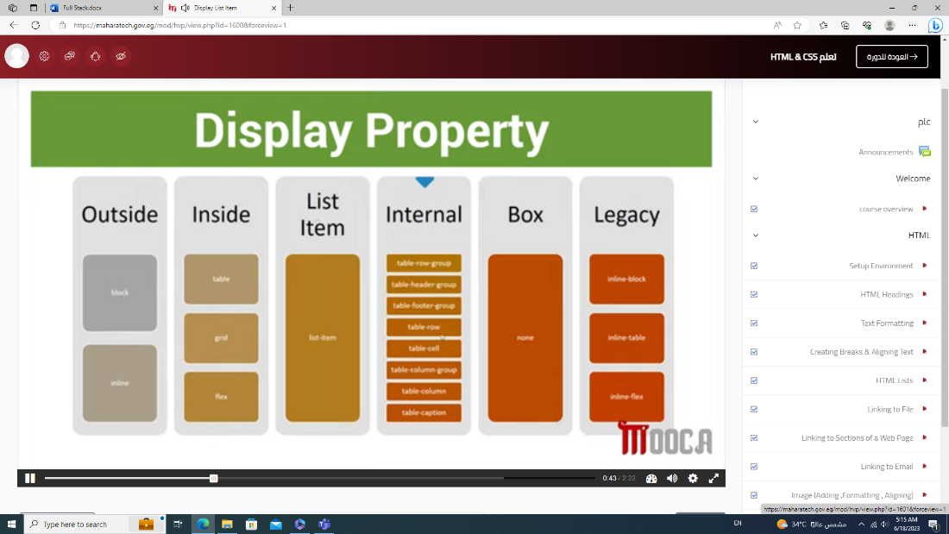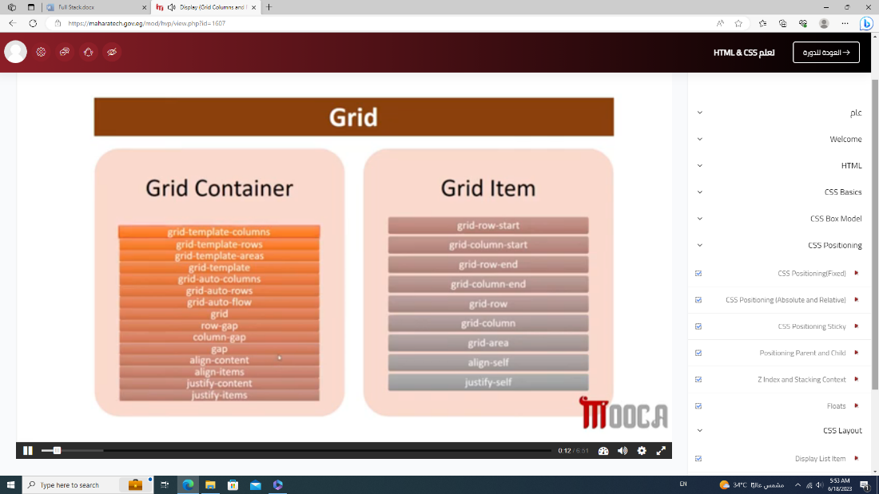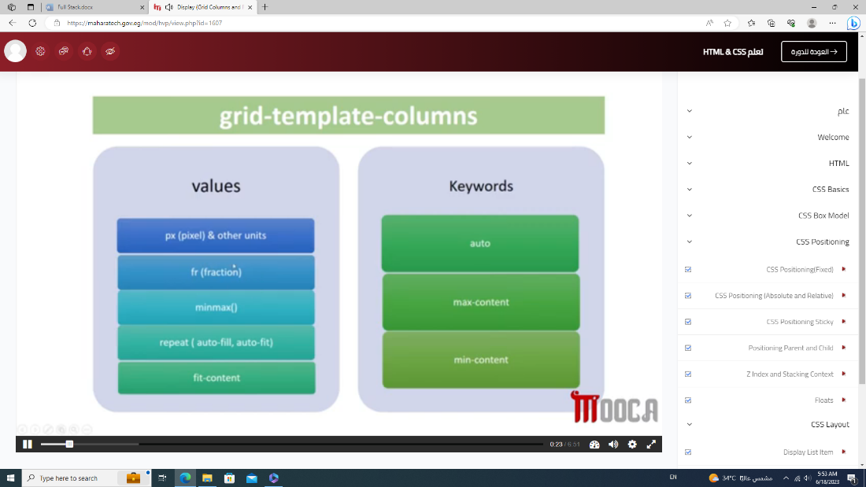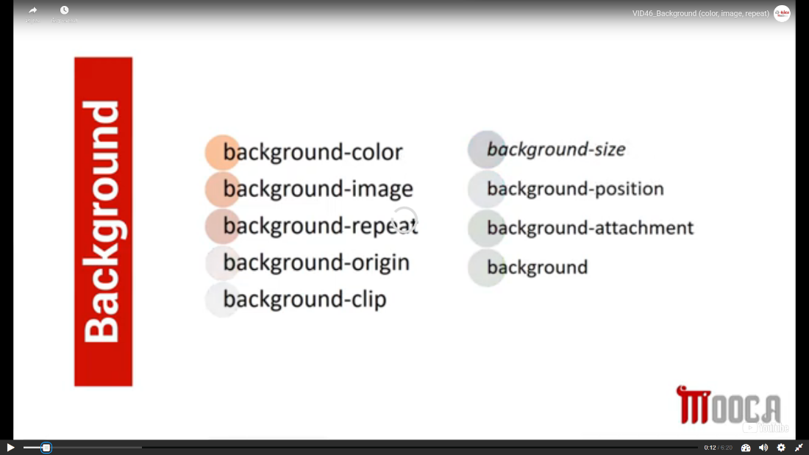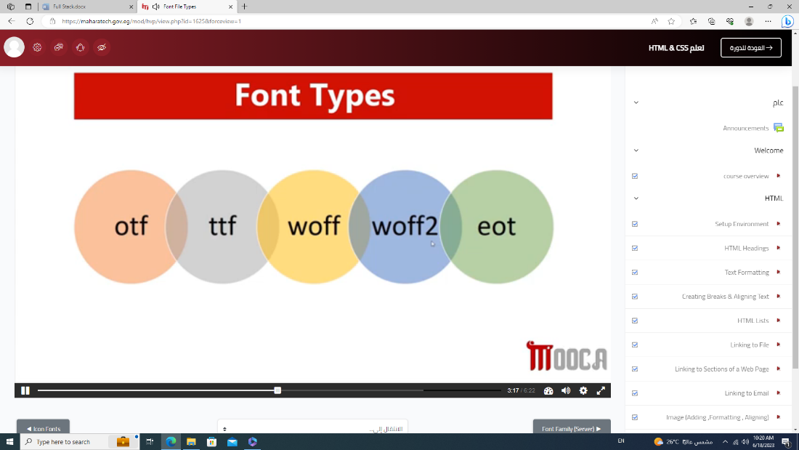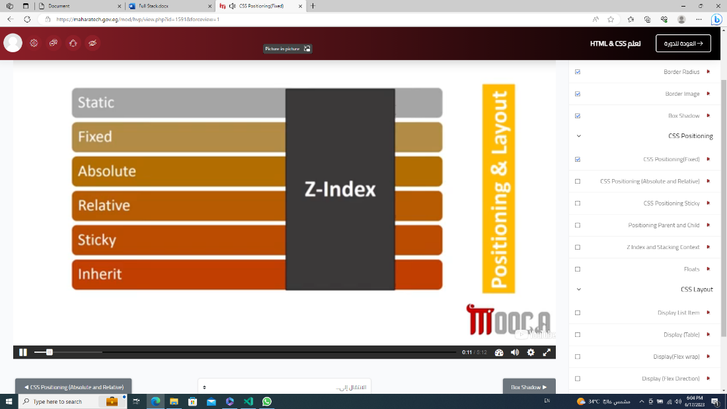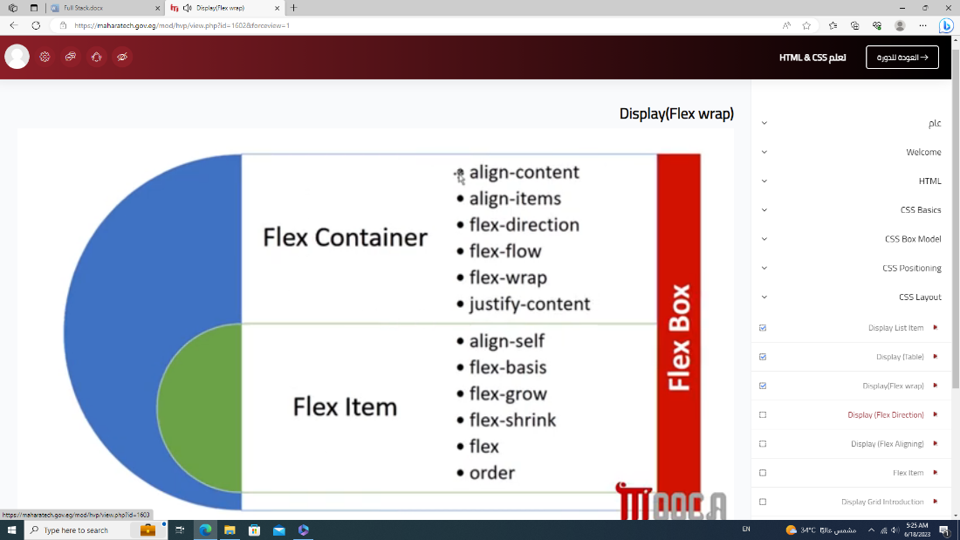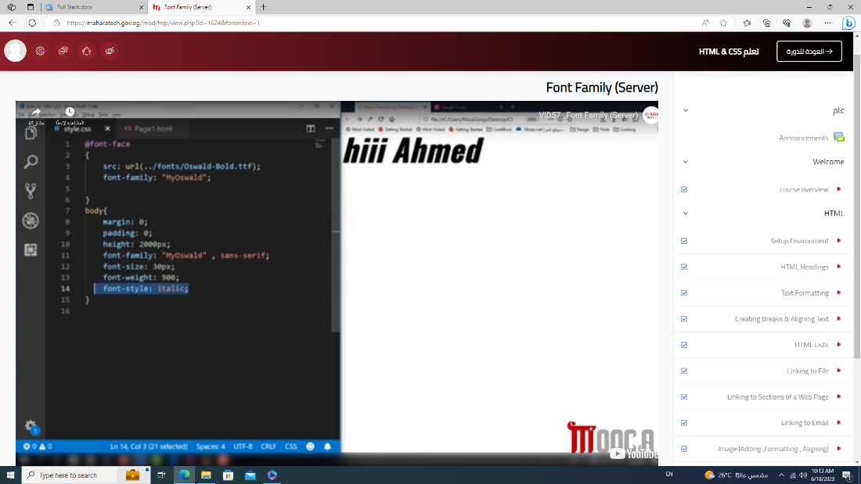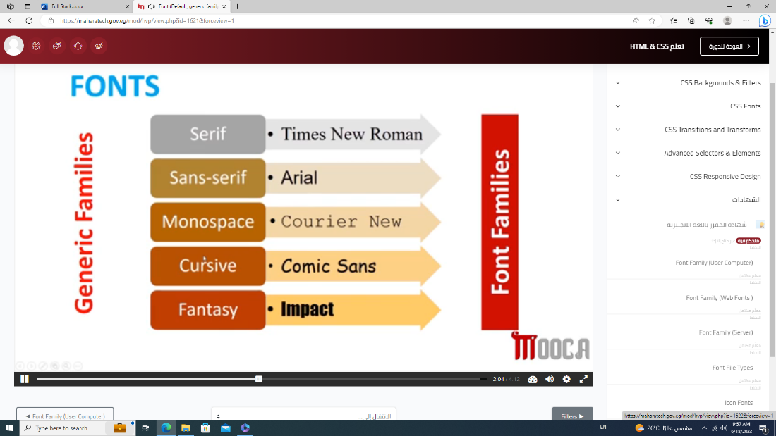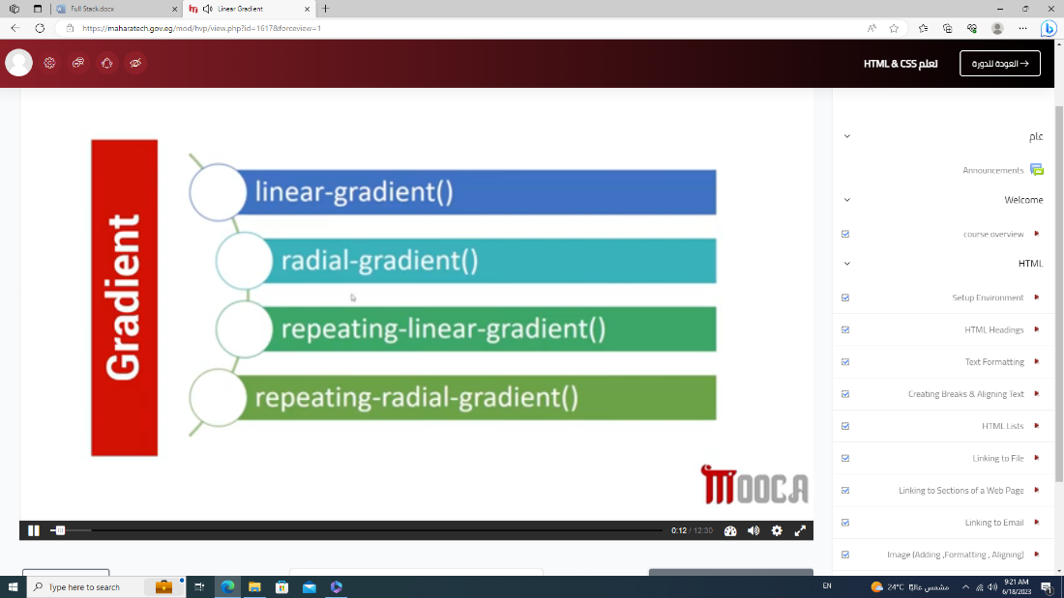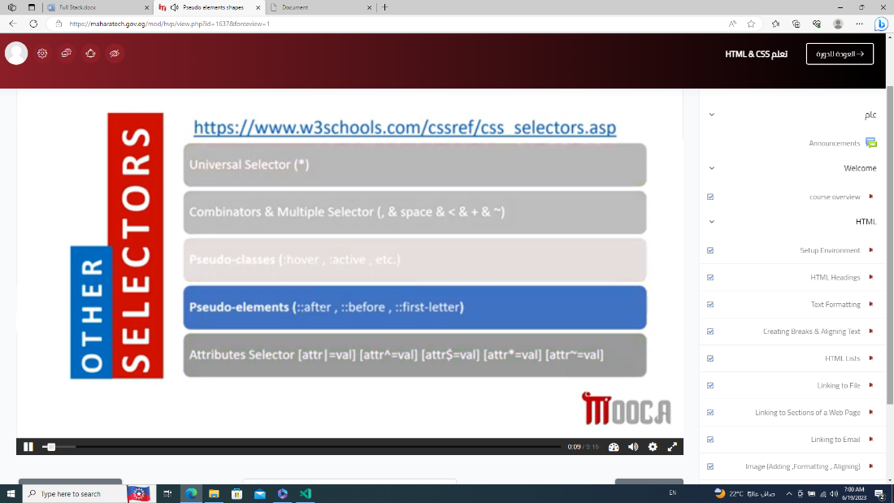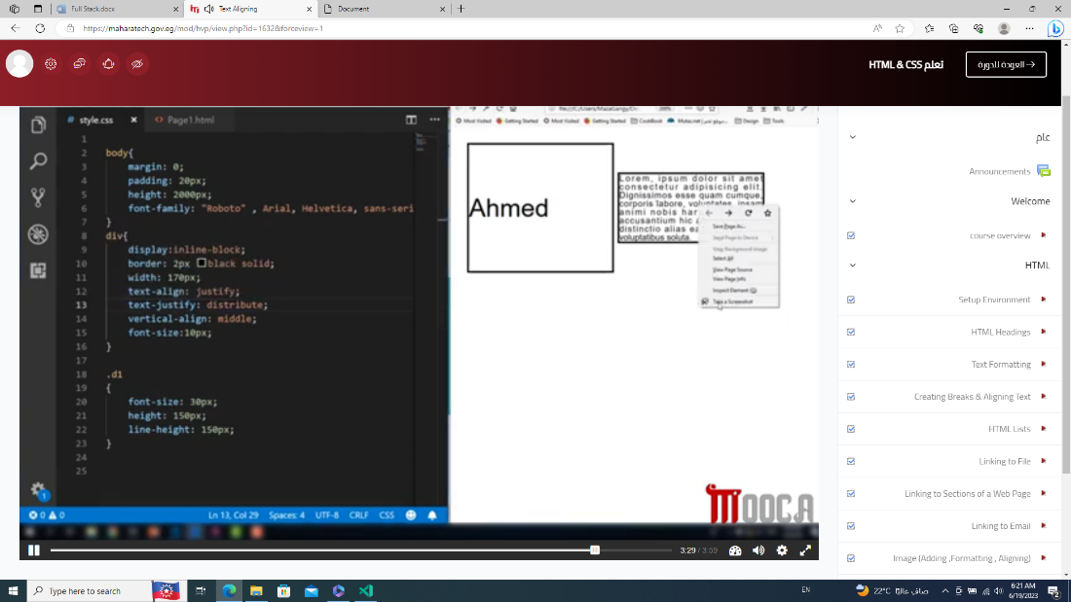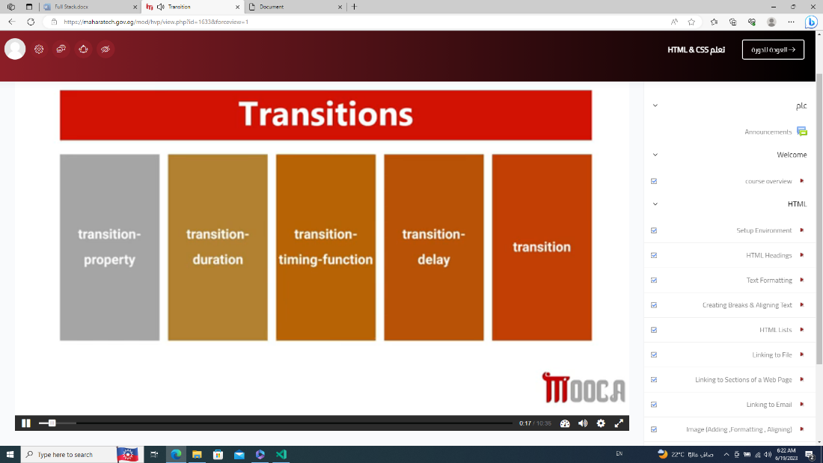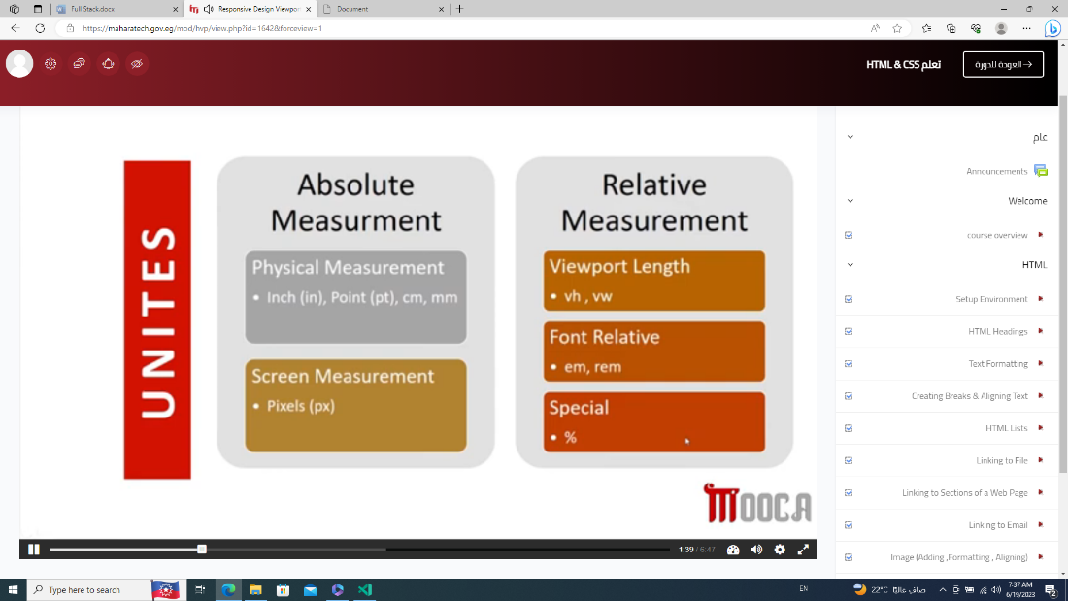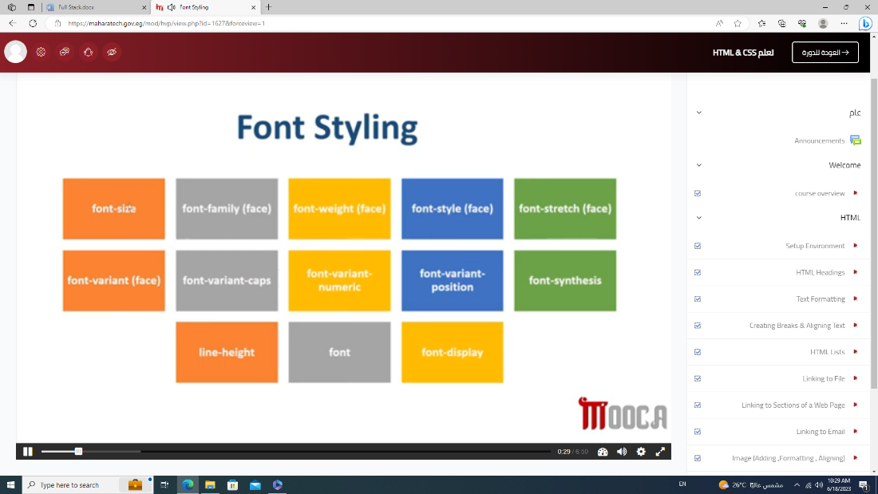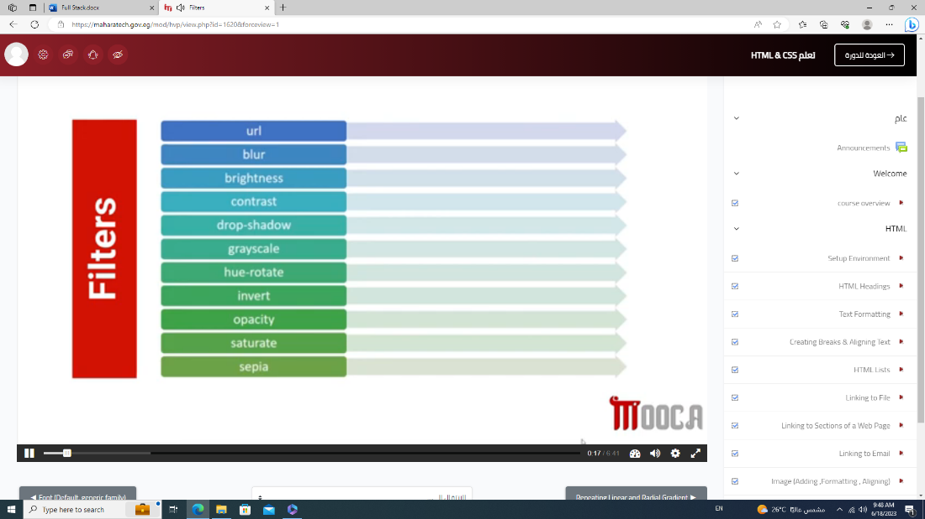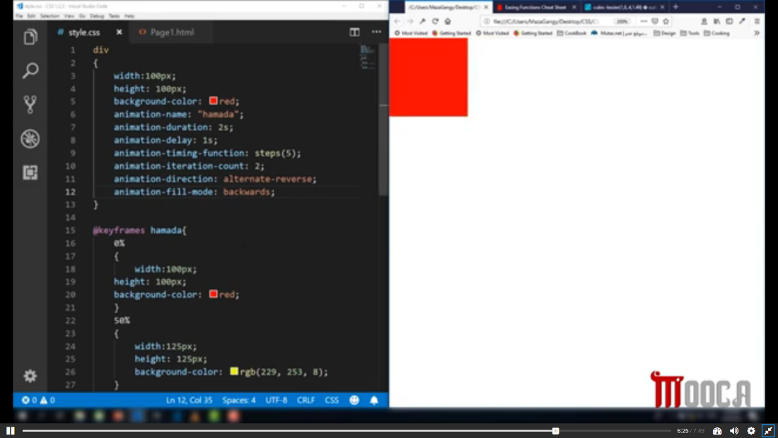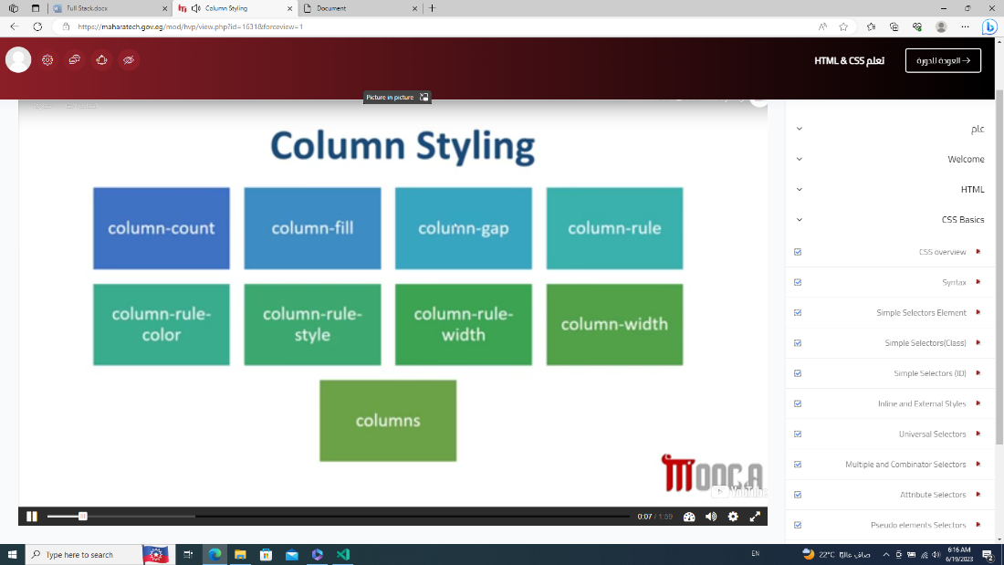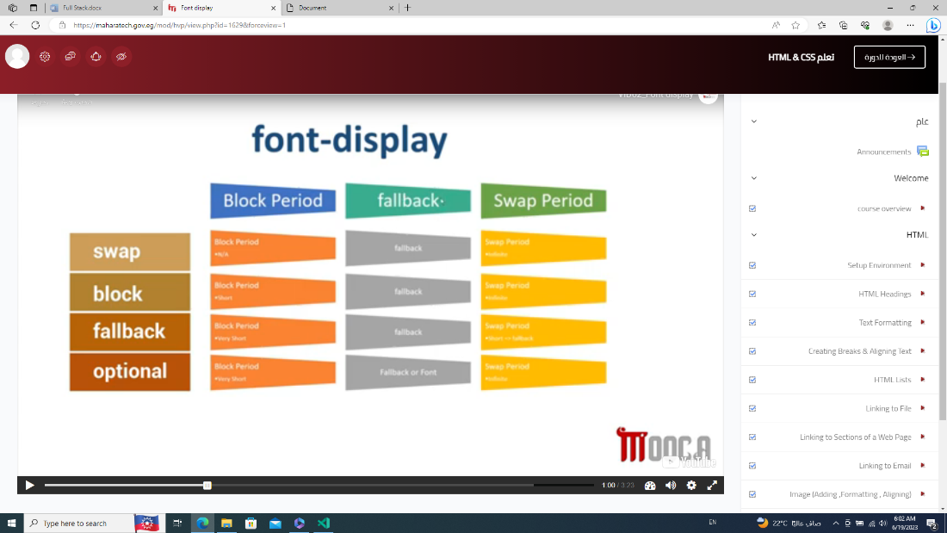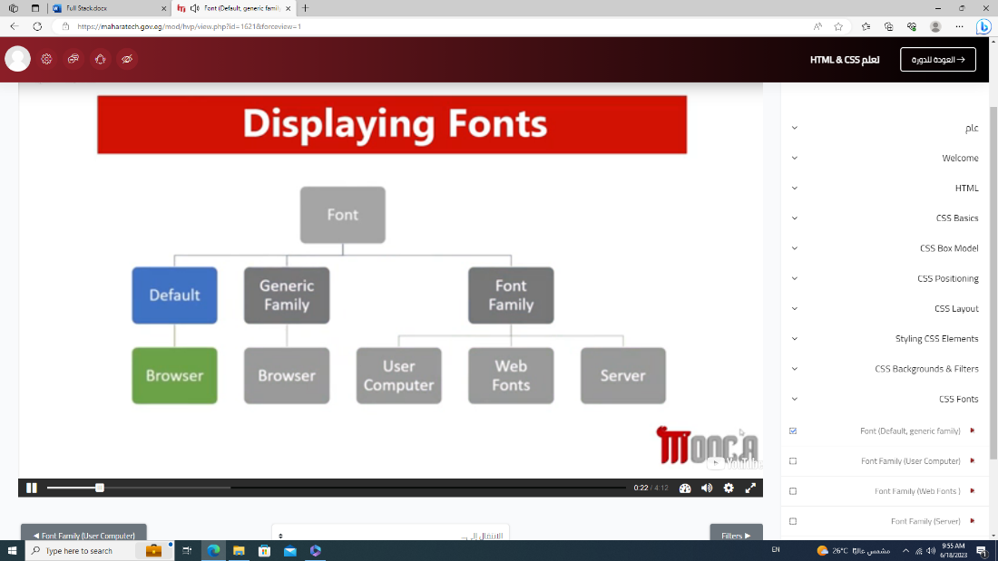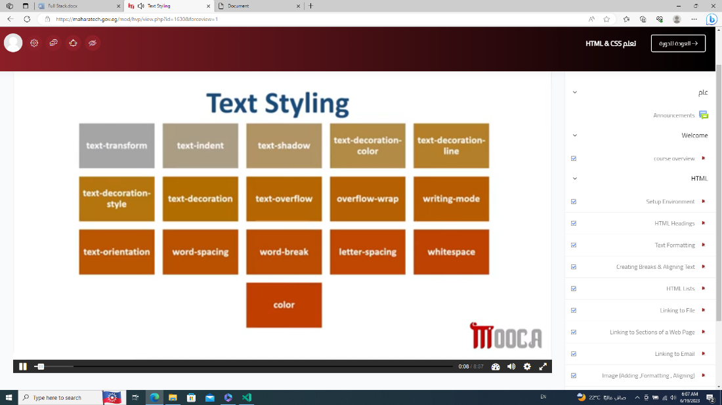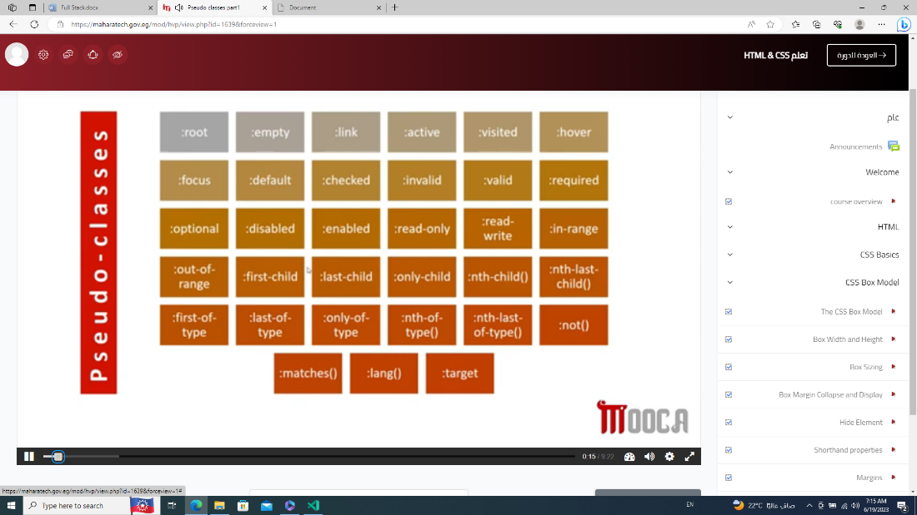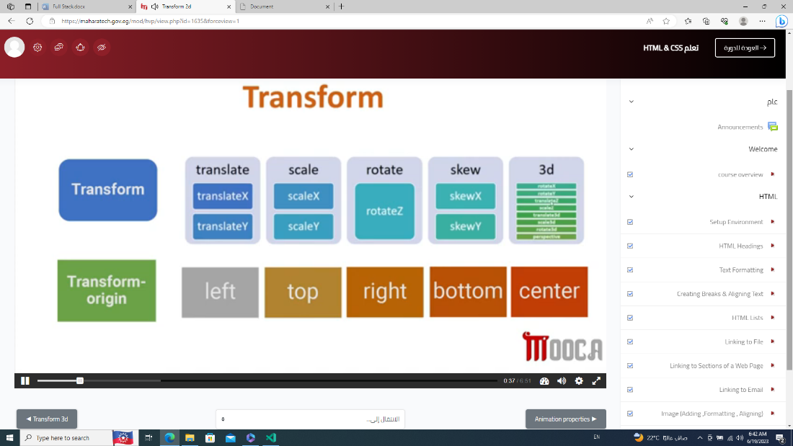

Attributes

* Align-items, valign, align, href

NOTES

* Absolute path -> writing to entire link
* Relative path

------------------------------------------------------------------------------------------------------------------------------------------------------------------------------------------------------------------------------------------------------------------------------------

CSS

* + Visibility(hidden) save location
  + Display(none) don`t save location
  + Transparent (شفاف)
  + Border-
    - Radius : inherit
    - Width
    - Color
    - Image: linear-gradient ( red, green)
    - Image-source: url(“”);
    - Image-source-slice: 40 fill
    - Image-width:
    - Image-repeat: round or space
    - Image-outset: 20px;
  + Border-radius : 50px / 20px 70px
  + Box-shadow: inset offsetX offsetY blur spread color
  + Position: sticky (fixed and relative) (fixed-> to move with scroll, relative-> move from location her)
  + Float, clear

Selectors

* ^ -> to start, $ -> to end, * -> to search it, ~ -> to search on the word alone, |-> to search on the word in start

Links

* Reset file (علشان يكون متظبط على اكتر من متصفح )
* Normalize
* Link of font
* Webfonts (inside of css file)
* All.min from fontawesome

*{

-webkit-box-sizing: border-box;

-moz-box-sizing: border-box;

Box-sizing: border-box;

}

.container{

Padding-left: 15px;

Padding-wright: 15px;

Margin-right: auto;

Margin-left: auto;  
}

Small

@media(min-width: 768px){ .container{width:750px} }

medium

@media(min-width: 992px){ .container{width:970px}}

Large

@media(min-width: 1200px){ .container{width:1170px} }

Bootstrap

* Consist of utility & component & grid.css
* CDN or Download
  + Because bootstrap is distributed on a server for each counter.
  + CDN-> takes it from the server of its country or a nearby one ( لو هيرفعه على الويب ).
  + Download -> ( يعنى هيستخدمه من غير نت فى حاله انه مش هيرفعه )
    - Choose compiled CSS & JS.
    - Remove map files.
    - bootstrap.min (minified (مضغوط))
    - Bootstrap. bundle (not use link popper)
* It is preferable to place the bootstrap file of CSS before the main CSS file
* mt-2 -> margin top 2px … m-auto
* border-top
* Classes
  + Container -> (بياخد المحتوى ويحطه فى النص )
  + Container-fluid -> (full width) (المحتوى بيبقى للصفحه كلها)
  + Row -> flex – wrap (يعنى div بيبقى جنب بعضه)
  + p-1 -> padding (0:5) …. p-1 = .25rem from all directions.
    - Rem -> from parent ( if parent is body -> .25rem = 4px ) ... note -> (body-> 16px)
    - Pt-4 -> padding-top ( pl -> left, pr -> right, pb -> bottom )
  + Col-1 -> one column
    - Col-md-3 -> three col of the medium screen (lg->large, sm-> small)
  + Text-center -> to put words in the middle
  + Text-(هيظهر كل الالوان المكتوبه ) like danger
  + btn
    - btn-(color).
  + Form-control -> to input

Links

* [Hello World (colorlib.com)](https://preview.colorlib.com/theme/poportfolio/)
* [1500+ Best Website Templates (HTML & CSS) 2023 - Colorlib](https://colorlib.com/wp/templates/) (for all templates)
* colorlib.com/preview/*pixcl

Notes

* [Your Recording 7.wav](https://fcihelwanedu-my.sharepoint.com/personal/amira_20210185_fci_helwan_edu_eg/Documents/Transcribed%20Files/Your%20Recording%207.wav)
* CSS -> bootstarp.min.css - style.css
* JS -> jquery - bootstrap.bundle
* Width of page -> 12 col

------------------------------------------------------------------------------------------------------------------------------------------------------------------------------------------------------------------------------------------------------------------------------------

***Java Script***

***Basic***

* Document.write();
* Alert();
* Prompt (); -> return value of text
  + Prompt (“what`s fav color” , “1)red 2)blue”); //1)red 2)blue appear in text
* Console.log(); console.error(); console.warn(); console.log(“%c message” , “color:blue;background:yellow”); %c -> to add style
* + -> to concatenate

***Functions***

* (123.45).toFixed(5); //123.45000 (range of toFixed (0:100))

***Built-In Functions***

* + ParseInt(x) -> return only number without (.) from string
    - X = “ad1312” // NaN (عمتا مش بتجيب الارقام اللى بعد الحروف)
    - X = “101abc” // 101
    - X = “101.01zcx” // 101
    - ParseInt(“0110” , “2(base)”) //6 -> convert from binary to number
  + ParseFloat(x)
    - X = “101.01.23.ab” //101.01 -> to limit first (.)
* IsFinite(x)
  + x = "1152.3433.43"; // false
  + X = 123456 // true
  + X = “234567” //true
  + X = “1234fvb345” // false
* IsNaN(x) -> inverse IsFinite(x)
  + X = 3456 //false
  + X = “3456dfg” // true
* DecodeURL()
* DecodeURLComponent()
* EncodeURL()
* encodeURLComponent()

***JS Built-In Objects***

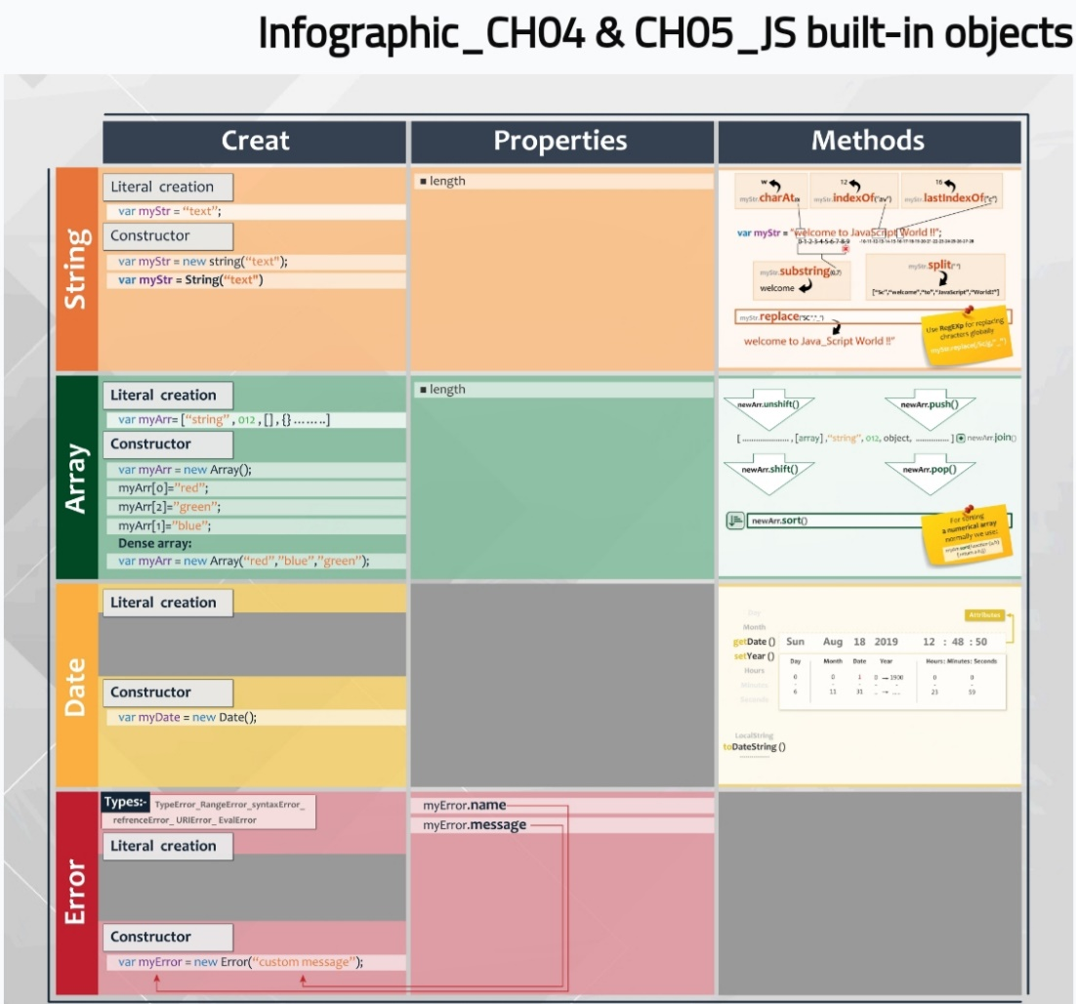

* String ex -> hello merOo
  + Ways of writing string
    1. Str.repeat(number);
    2. Var str = “message”; //string
    3. Var str = new String(“message”); //object
    4. Var str = String(“message”); //string
  + 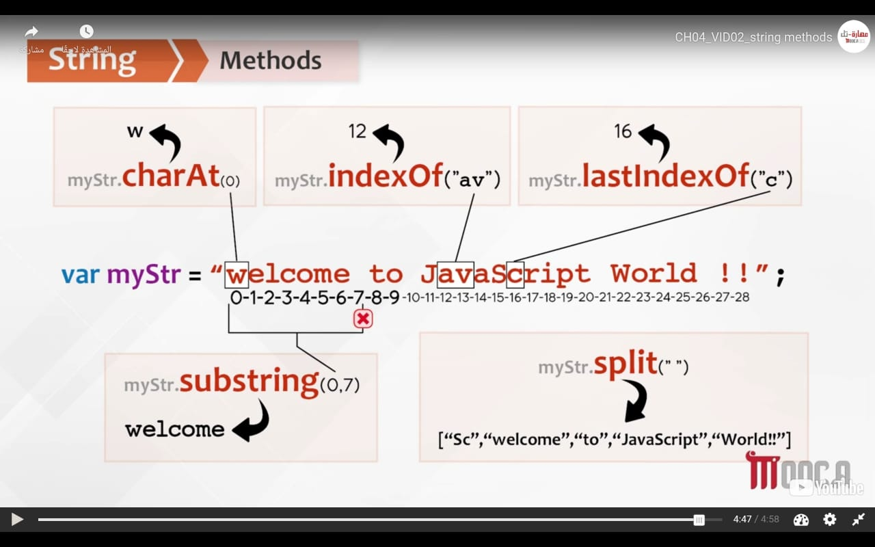
  + Str.Length // 11
  + Str.charAt(6) // m
  + Str.indexOf(“e”) if not found will return –1 //1
  + Str.lastIndexOf(“e”) //7
  + Str.substring (1, 4) -> (اقص الاسترينج) // ell
    1. The end not print
  + Split(“ ”) // [“hello” , “merOo”]
    1. Split(“”) // each character message.split(“s”); //[‘me’ , ‘ ’ , ‘age’]
* Replace ( /pattern/flag (i (ignore small or capital ), m (multiple lines) -> (بدلى اول حرف اللى كتباه بس), g (global) ) , “”)
  + Replace(/e/ , “_”) // h_llo merOo
  + Replace(/e/ g , “_”) // h_llo m_rOo
  + Replace(/o/ gi , “_”) // hell_ m_r__
* Array
  + Length
  + Dense Array -> var color = new Array (“red” , “blue” , “green”)
  + Arr.join(“”); convert array to string
  + (اللى بيأثر فى الاري)
    1. Arr.push(); addition in ending array arr.unshift(); addition in start array
    2. Arr.pop(); remove last element arr.shift(); remove first element
    3. Arr.reverse();
    4. Persons.splice(start, number remove); splice(2 , 1) -> meaning (امسح العنصر التانى فقط)
  + Associative array -> (كل اللى موجود فى الاراى العاديه مش بيأثر عليها )
    1. NOTE-> (لو كتب الانشيفت او البوش هيضاف فى الاول ولو حسبت اللينث هيحسب اللى الكيي بتاعه ب صفر )
    2. Var ass = new Array ();
    3. Ass[“first”] = “mrmr”; first -> key , mrmr -> value
    4. For( i in ass){ console.log(ass[I]) }
* Date
  + Var today = new Date(); //current date || Var today = new Date(“Jul 6, 7”);
  + Date.now();
  + Date.parse(“date”); // return ms
    1. GET -> get information from date
       - Today.getDate(); //day (starting 1)
       - Today.getMonth(); //number of month (starting zero)
       - Today.getYear(); //year-1900 (ex-> if year = 2019 then output is 119)
         * Today.getFullYear(); //year
       - Today.getDay();
       - Today.getHours();
       - Today.getMinutes();
       - Today.getSeconds();
    2. SET -> change date
       - Today.setTime(1000); // from starting + 10000 ms
       - Today.setDate(7);
         * Change day to 7
       - Today.setMonth(10);
         * Change month to November (11);

because month starting with zero

* + - * Today.setFullYear(2020 , 2); //2 -> march
    1. Format
       - Today.toDateString(); //thu jun 15 2023
       - Today.toLocaleString(); // 6/15/2023, 3:44:31 pm
* Error-Object
  + 1. Types
       - Reference Error -> invalid reference is used (بشاور على متغير مش موجود)
       - Eval Error -> (بستخدم الfunctionبطريقه غلط)
       - URLError -> encodeURL() or decodeURL() are used incorrectly
       - Syntax Error -> ex (لما انسى احط اقواس )
       - Type Error -> ex (console.logg) error in word
       - RangeError -> (123.45).toFixed(101); because range of toFixed (0:100)
  + Var myError = new Error(“Custom Error”); (كده مش هيظهر )
    1. Throw myError (كده هيظهر الكلمه بدل نوع الخطأ)
    2. Throw “message”; //uncaught message
    3. Throw new RangeError(“message”); (call RangeError ) //uncaught RangeError: message
    4. Console.log(myError.name); //Error
    5. Console.log(myError.message); // Custom Error
    6. Statement after error doesn`t execute
  + JS Error Handling
    1. Try{} … catch(e){} … finally{}
       - [try ... catch](https://fcihelwanedu-my.sharepoint.com/personal/amira_20210185_fci_helwan_edu_eg/Documents/Transcribed%20Files/Your%20Recording%2017.wav)
       - (اول ما يلاقى خطأ فى تراى هيعمل اسكيب لباقى التراى ويروح على الكاتش ولو فى حاجه تتنفذ بعد الكاتش هيروحلها )
       - Statement of catch only execute if exit error
       - (لو فى خطأ فى الكاتش هيظهر الخطأ ومش هيظهر اخر جمله)
       - Finally -> (بيتكتب بعد الكاتش علشان لو فيها خطأ هيظهر الخطأ عادى وهيطبع اللى جوه الفاينلى)
       - [catch(e)](https://fcihelwanedu-my.sharepoint.com/personal/amira_20210185_fci_helwan_edu_eg/Documents/Transcribed%20Files/Your%20Recording%2018.wav)
       - Catch(e) { if (e instanceof RangeError) {} else if (e == “message”) {} }
    2. Onerror event
       - [OnError event](https://fcihelwanedu-my.sharepoint.com/personal/amira_20210185_fci_helwan_edu_eg/Documents/Transcribed%20Files/Your%20Recording%2019.wav)
       - 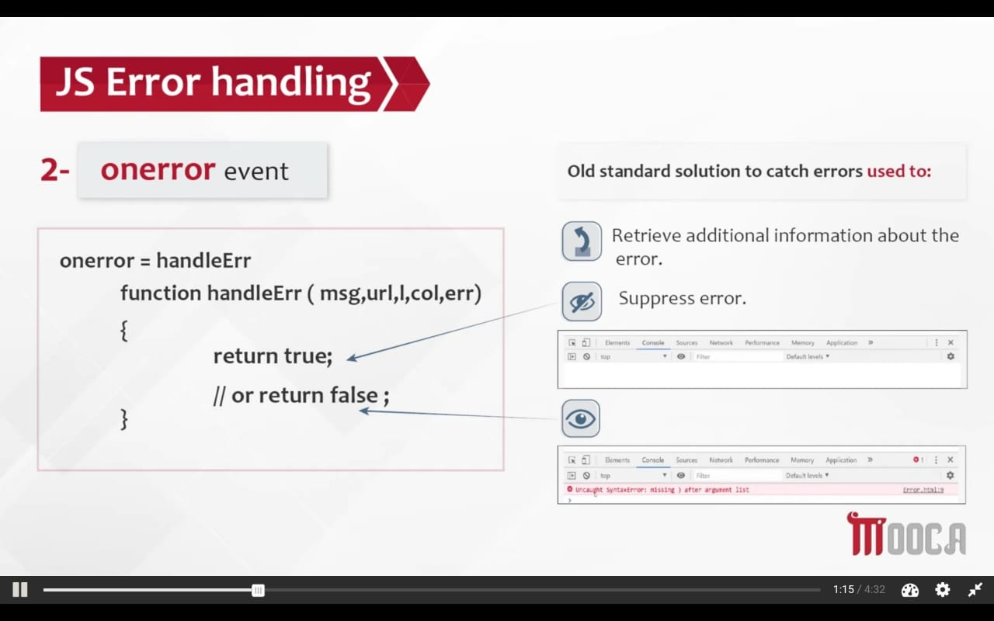
* Function Object
* IIFE -> Immediately Invoked Function Expression (بنادى عليها مره واحده بس وبتبقى ملهاش اسم)
  + (function(){
  + console.log("hii");
  + })()
* //problem
* function outer(){
* var arr = [];
* for(var i=0; i<3; i++){
* arr.push(function(){
* console.log(i);
* })
* }
* return arr;
* }
* var result = outer();
* result[0](); //3
* result[1](); //3
* result[2](); //3
* //solution using IIFE Pattern
* function outer(){
* var arr = [];
* for(var i=0; i<3; i++){
* arr.push((function(){
* console.log(i);
* })());
* }
* return arr;
* }
* var result = outer();
* result[0]; //0
* result[1]; //1
* result[2]; //2
  + 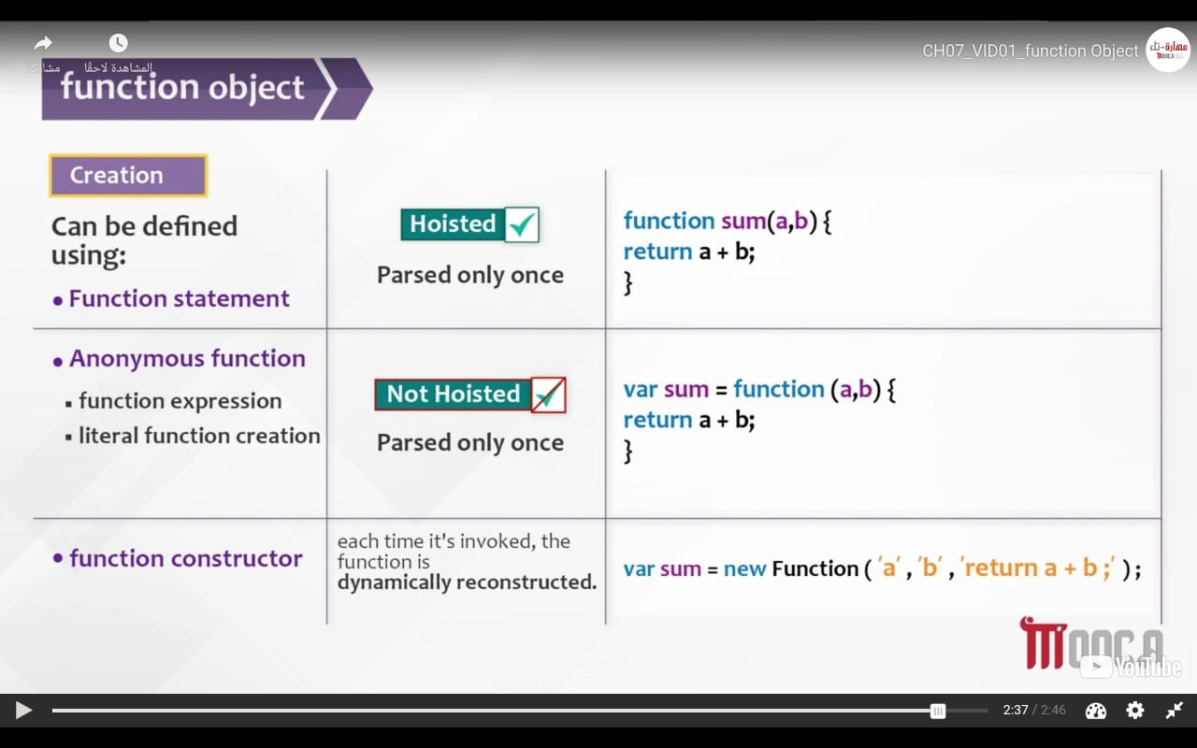
  + Arguments
    1. Arguments.length (علشان اعرف الفانكشن هيجيلها كام باراميتر)
       - function sum(){
       - var result = 0;
       - for(var i=0; i<arguments.length; i++){
       - result += arguments[i];
       - }
       - return result;
       - }
       - console.log(sum(1 , 4 , 5));
  + Trying use join with string ex var str = "this ia JavaScript";
    1. //function borrowing using apply

console.log([].join.apply(str , ["**"])); //t**h**i**s** **i**a** **J**a**v**a**S**c**r**i**p**t

* + 1. //function borrowing using call methodconsole.log([].join.call(str , "**")); //t**h**i**s** **i**a** **J**a**v**a**S**c**r**i**p**t
    2. //binding

var result = [].join.bind(str , "__");

console.log(result("**"));

//t__h__i__s__ __i__a__ __J__a__v__a__S__c__r__i__p__t

* + 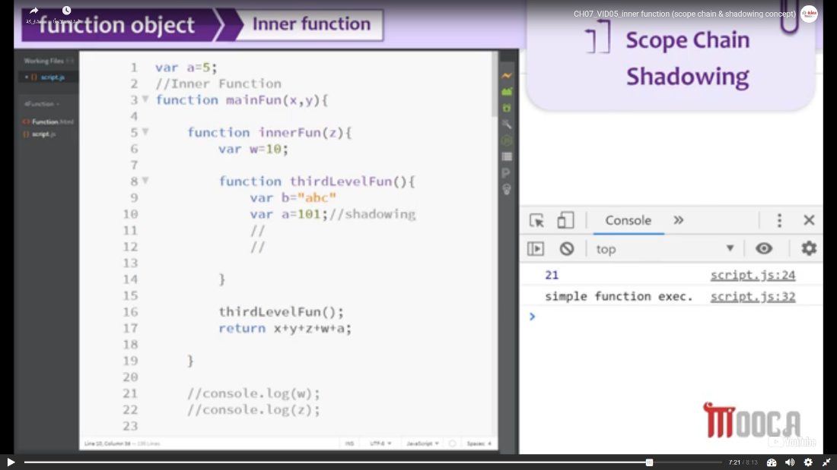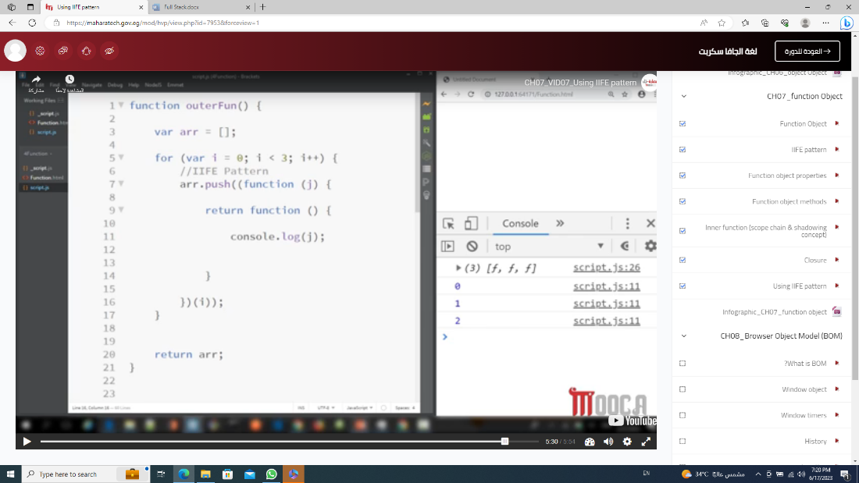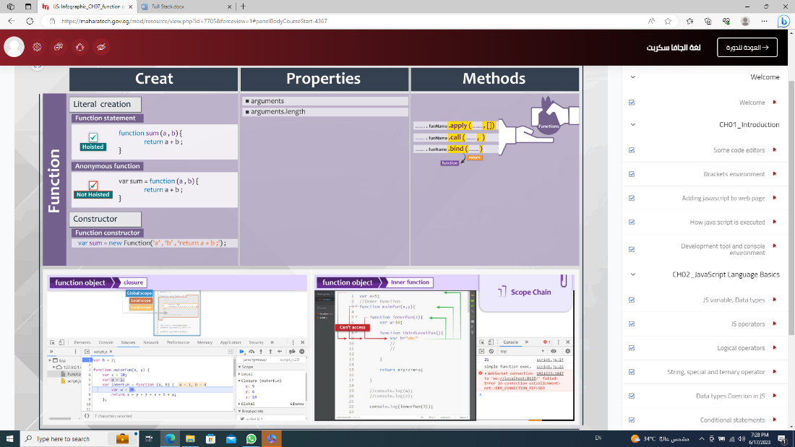
  + Fc
* Object
* Instant method
  + Obj.hasOwnProperty(“name of key”); //true or false
  + Obj.toString(); //[object Object]
* Static method (Class method)
  + Object.steal(obj);
  + Object.freaze(obj);
  + Object.keys(obj);
  + Object.values(obj);
  + delete obj.key of obj;
  + Use of For (in)
  + To prevent deleting from obj , for(in) , obj.p2 = “newVal”

Object.defineProperty(obj , “name of property ”, {}) // To each property

* + - Value -> default(undefined) -> value of property
    - Writable -> default (false) -> Don`t allow to set a new value
    - Configurable -> default (false) -> Don`t allow to delete property
    - Enumerable -> default (false) -> property will not appear in for(in)
    - Set : function(val){ variableName = val} to change value
    - Get : function(){return variableName} to see the value
      * var obj = {"myName" : "amira" , "age" : "19"};
      * Object.defineProperty(obj , "myName" , {
      * value : "amira",
      * writable : false,
      * configurable : false,
      * enumerable : false
      * })
      * for(i in obj){
      * console.log(obj[i]); // 19
      * }
      * obj.myName = "meroo";
      * console.log(obj.myName); // amira
      * delete obj.myName;
      * console.log(obj.myName); // amira
    - Object.defineProperties(obj , { property:{}, property:{} })
      * var obj = {"myName" : "amira" , "age" : "19"};
      * Object.defineProperties(obj , {
      * myName:{
      * value : "amira",
      * configurable : false
      * },
      * age : {
      * value : "19",
      * writable : true
      * }
      * })
      * delete obj.myName;
      * console.log(obj.myName); //amira
      * obj.age = "20";
      * console.log(obj.age); //20
    - NOTE ->
      * Data Descriptor contains (value, writable)
      * Accessor Descriptor contains (set. get)

var myName = "amira";

var age = "19";

var obj = {};

Object.defineProperties(obj , {

myName:{

get : function(){return myName;},

set : function(val){myName = val;},

configurable : false

},

age : {

value : "19",

writable : true

}

})

obj.myName = "meroo";

console.log(obj.myName); //amira

// Factory Method

* function employee(nm , dep , sal){
* return {
* empNumber : nm,
* empSalary : sal,
* empDep : dep,
* info : function(){
* return "employee works in dept " + this.empDep + "and empNumber is " + this.empNumber;
* }
* }
* }
* console.log(employee("amira" , "it" , "100000")['info']());
* // Constructor Method
* function Employee(nm , dep , sal){
* this.empNumber = nm;
* this.empSalary = sal;
* this.empDep = dep;
* }
* var emp = new Employee("amira" , "it" , "10000");
* console.log(emp.empNumber);
  + 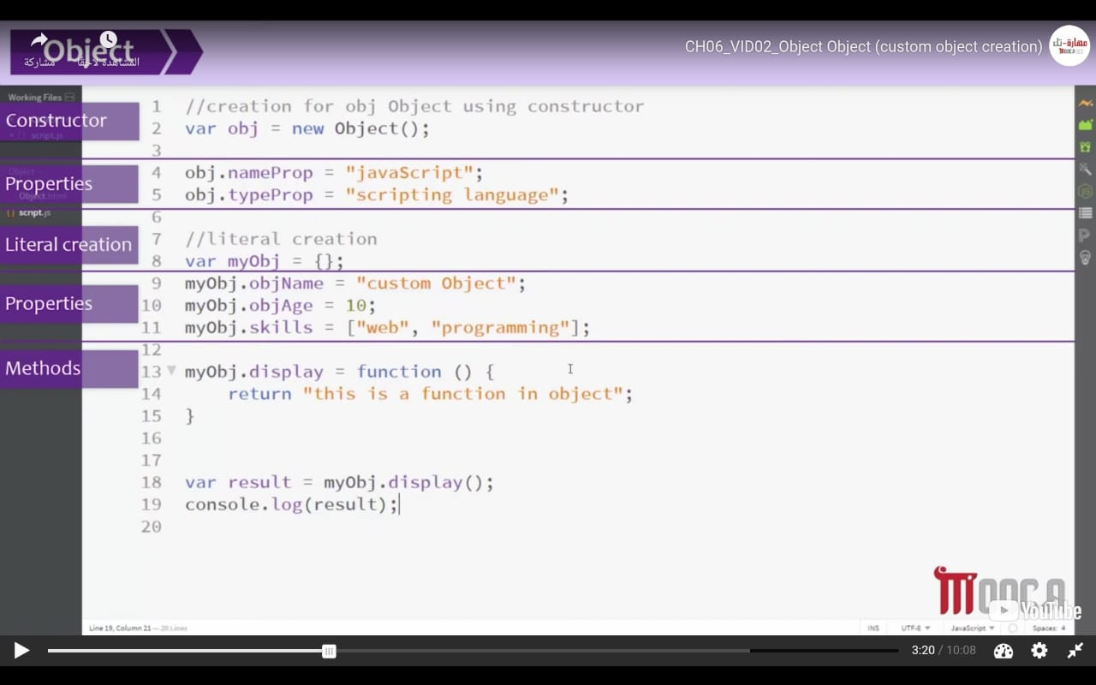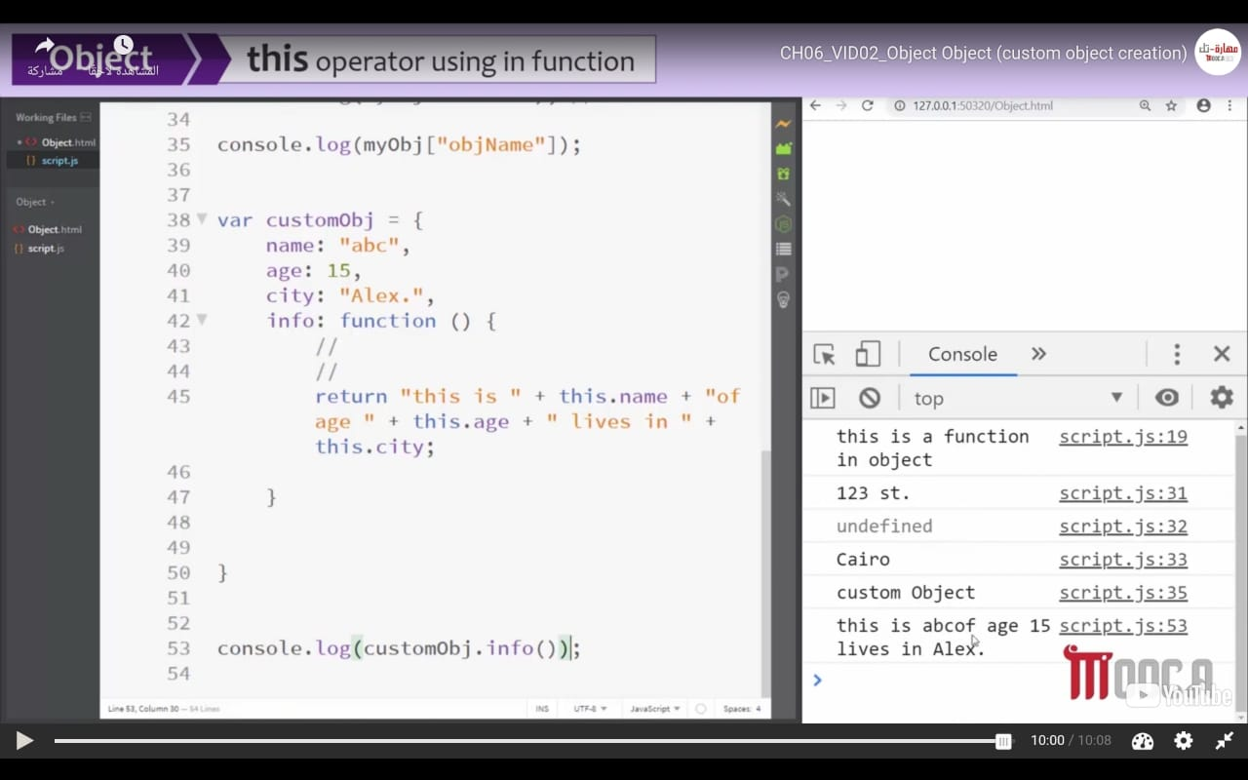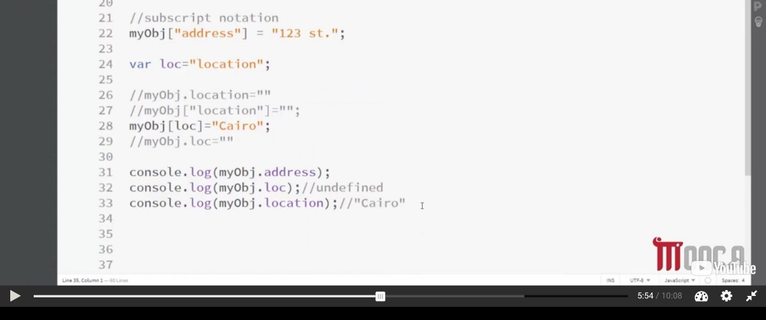

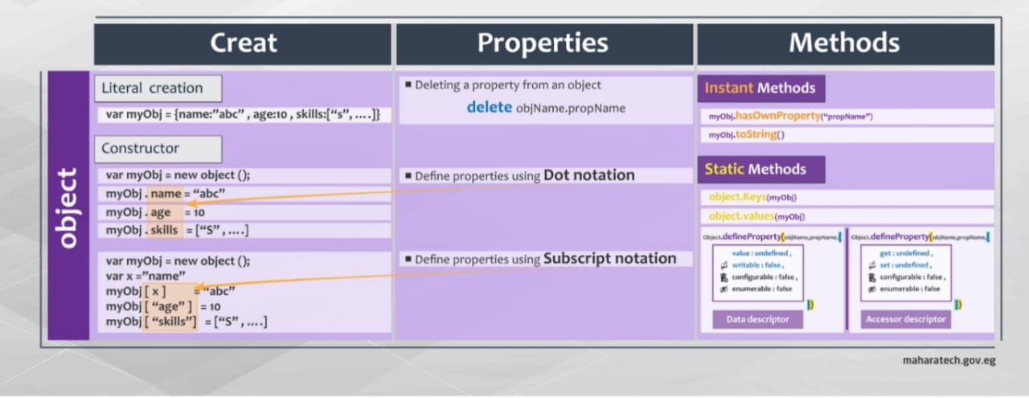

NOTE -> Dot notation

objName.property = value

Subscript Notation

objName[“property”] = value

***BOM -> (document object model)***

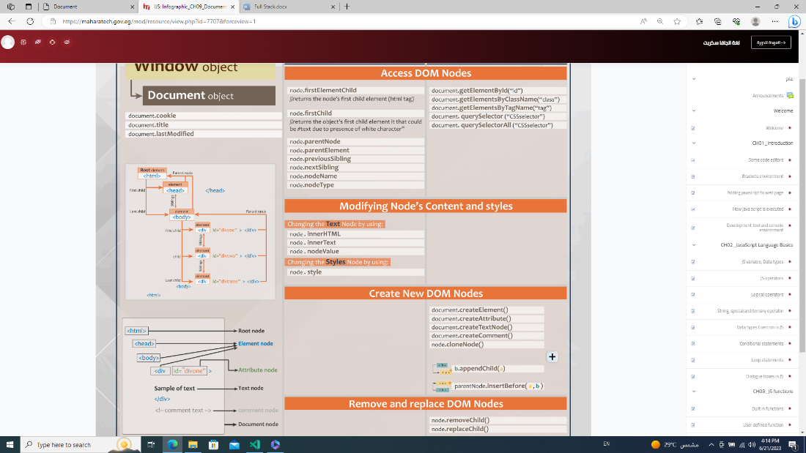

* Window
  + 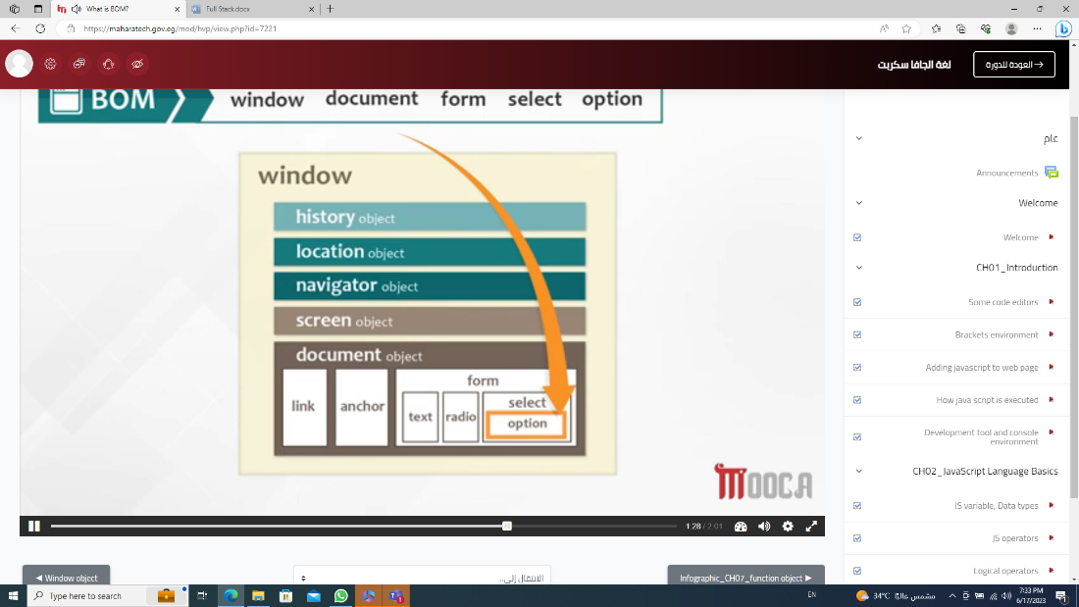
  + .resizeBy(), .resizeTo(), scrollBy(), scrollTo()
  + 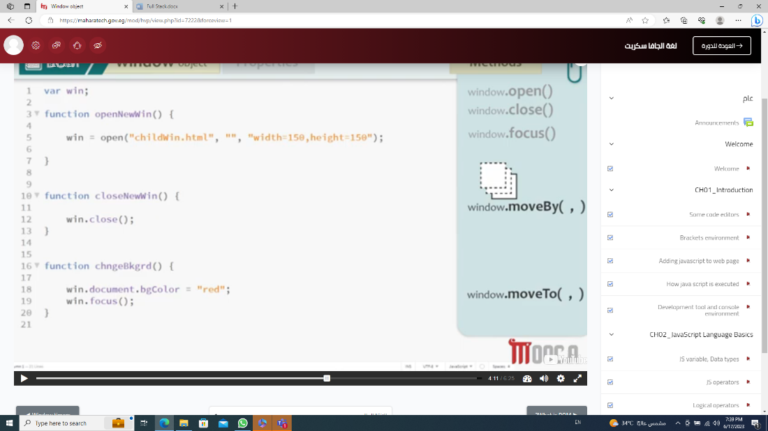
  + // SetInterval(fun , duration) & clearInterval(name variable of setInterval)
* var stop;
* function start(){
* stop = setInterval(function(){
* console.log("hello merooo");
* } , 2000)
* }
* function end(){
* clearInterval(stop);
* }
  + // setTimeout(fun , duration) -> (appear only once )& clearTimeout()

var stop;

function start(){

console.log("hiii merOoo");

stop = setTimeout(start , 2000);

}

function end(){

clearTimeout(stop);

}

* History (count tab)
  + .length
  + .go(negative to back or positive to forward)
  + .forward()
  + .back()
* Location
  + .href (to get url)
  + .protocol
  + .host or .hostname
  + .replace(“url”)
  + .assign(“url”) -> (remove all forward and reach to page of url)
  + .search -> (to get query from form)
    - Ex -> (?username=Ali found in url)
  + .reload()
* Navigator (language related to browser)
  + .appCodeName -> (to know name of browser but it isn`t clear)
  + UserAgent -> (to know name of browser as string and clear )
  + .cookieEnabled -> (to know, if user allow put cookie)
  + .language
  + .platform -> (to know operating system that client use it)
* Document (contain all HTML)
  + Console.dir(document) -> to view DOM prosperities
  + .body.children[0].nextElementSibling
  + // Ways to select element
    - 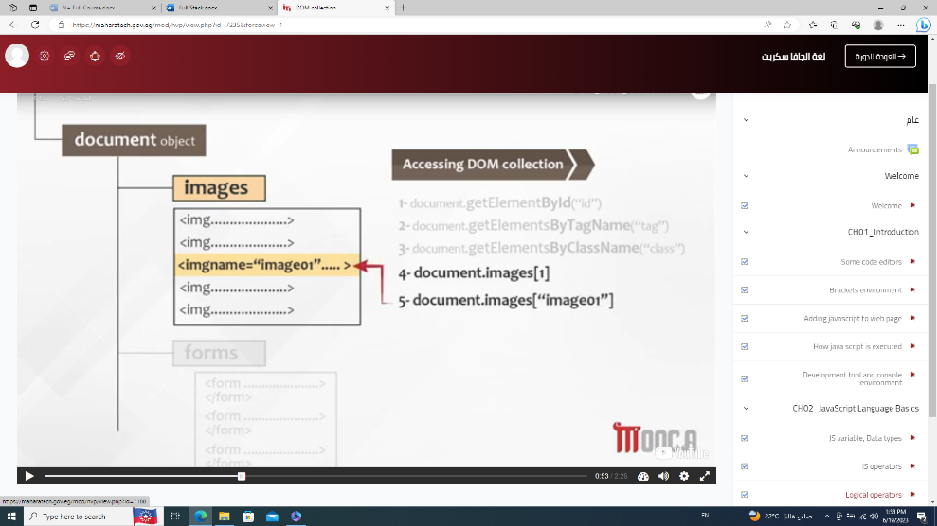
    - .getElementById(“”)
    - .getElementsByClassName(“”)
    - .getElementsByTagName(“”)
    - .querySelector(‘#id or .class’);
    - .querySelectorAll(‘’);
  + .innerHTML = “”;
  + .innerText = “”;
  + (call div, p or ...).className -> return name of class
  + (call div, p or ...).classList.add(“name of new class”)
  + (call div, p or ...).classList.remove(“name of new class”)
  + GetComputedStyle(call div, p or ...).color // (بسأل لونه ايه وهكذا مع باقى )
  + Body.insertBefore(اللى عايزه احطه , b )
  + .appendChild();
  + CreateElement();
  + CreateAttribute();
  + CreateTextNode();
  + CreateComment();
* Cookie
  + Persistent -> has an expire date
  + None-persistent(session)
  + 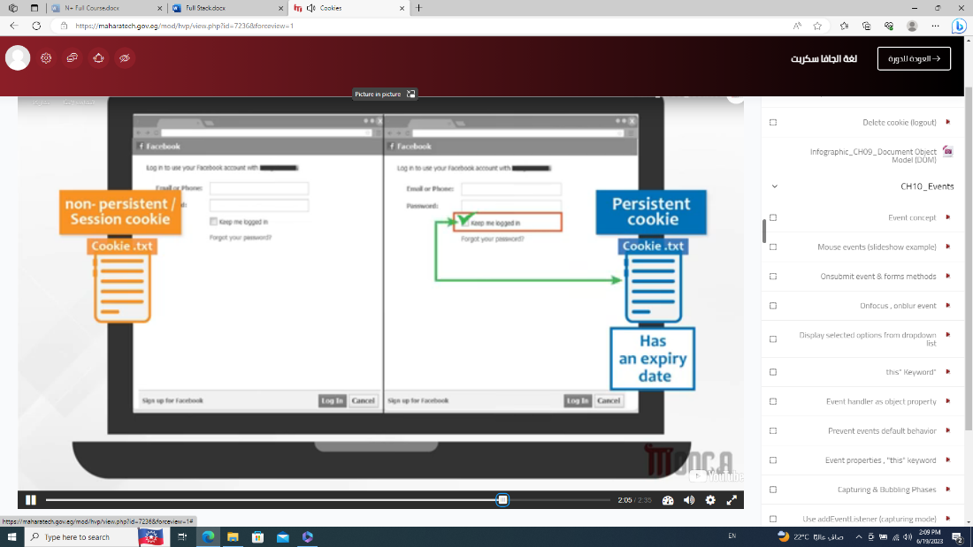
* Events
  + 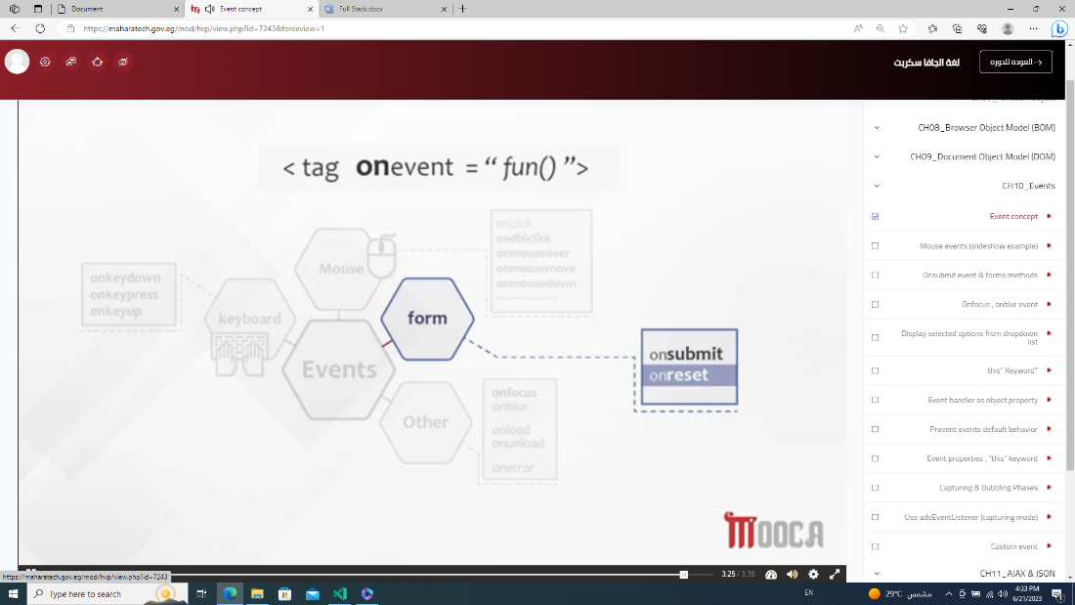
  + Onmouseover();
  + Onmouseout();
  + .onmousemove
    - document.getElementById('move').onmousemove = function move (e) {
    - document.getElementById('move').innerHTML = e.clientX;
    - }
    - e.clientX (from starting page)
    - e.offsetX (start from element )
    - e.target (info about event)
    - e.type (type of event)
  + FORM
    - Onsubmit

JS

* + - * document.forms[0].onsubmit = function(){
      * alert(document.getElementById('inp').value);
      * }

HTML

<form action="">

<input type="text" value = "hii" id="inp" placeholder="name">

<button type="submit">submit</button>

</form>

* + - Onreset
    - Onfocus
    - Onblure
      * <input type="text" value = "hii" id="inp" placeholder="name" onblur="this.value='nothing'">
  + Dropdown list
    - .length
    - .selectedIndex (return a number of option who user choose it)
    - .options[] (return all options who user choose it)
      * .options[].selected
      * .options[].text
      * .options[].value
  + THIS
    - 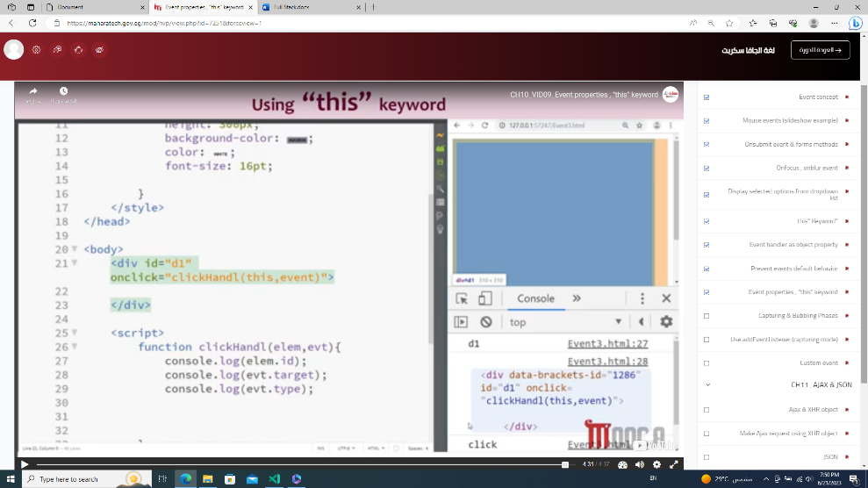
    - 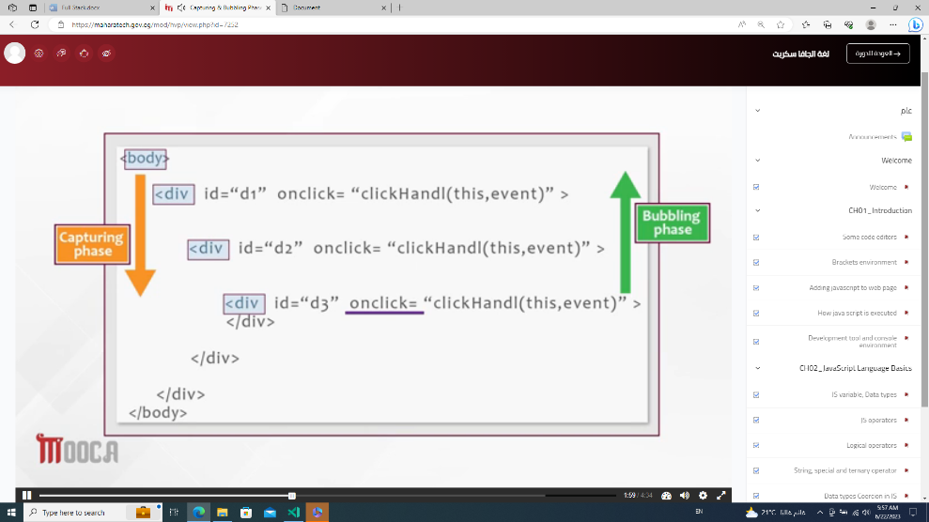
    - Event.stopPropagation()
    - AddEventListener(“click” , function(){} , true or false)
      * True -> capturing mode (لو استخدمتها مع stopPropagation هيظهر اول div بس)
      * False -> bubbling mode

To Create Event

* //create
* var newEvent = new Event("seen");
* // listen
* document.getElementsByTagName("div")[0].addEventListener("seen" , function(){
* console.log("seen Event fired");
* });
* // fire
* setTimeout(function(){
* document.getElementsByTagName("div")[0].dispatchEvent(newEvent);
* } , 1000);
* 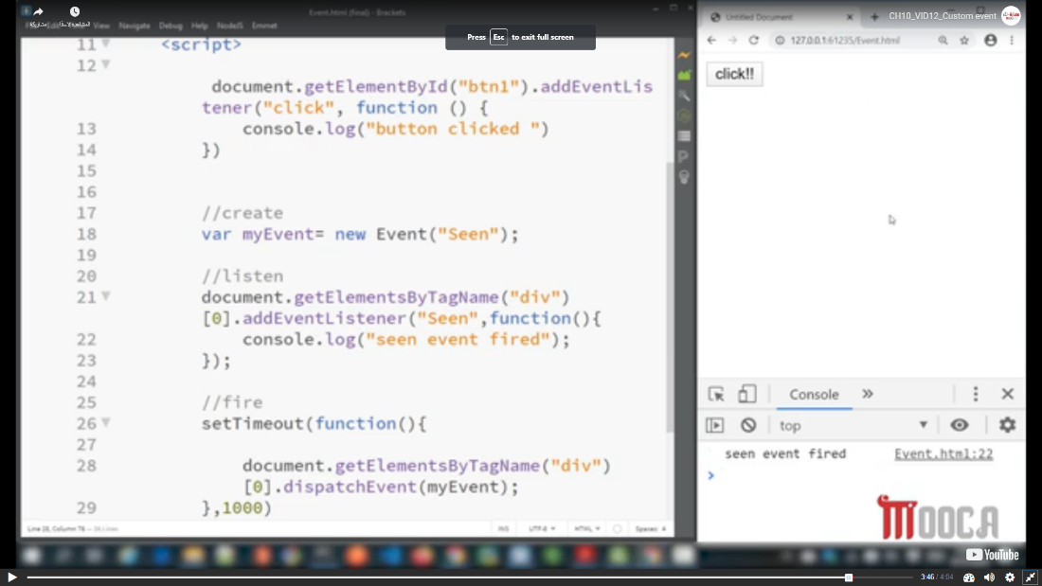
* 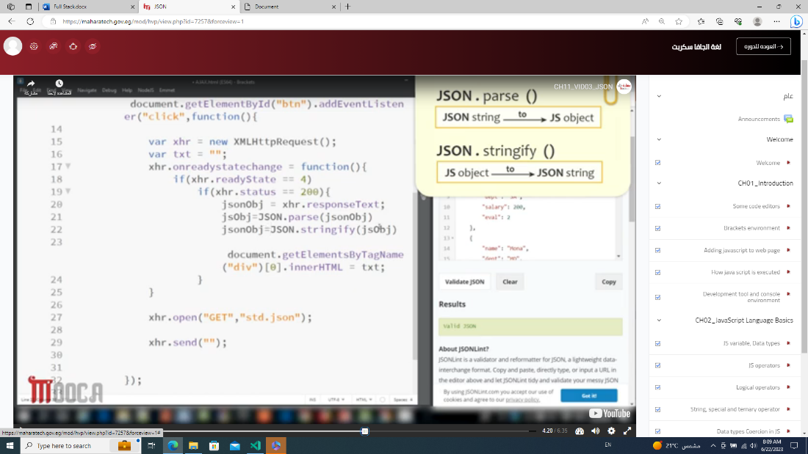

***Custom Function***

1. Statement & anonymous
   1. 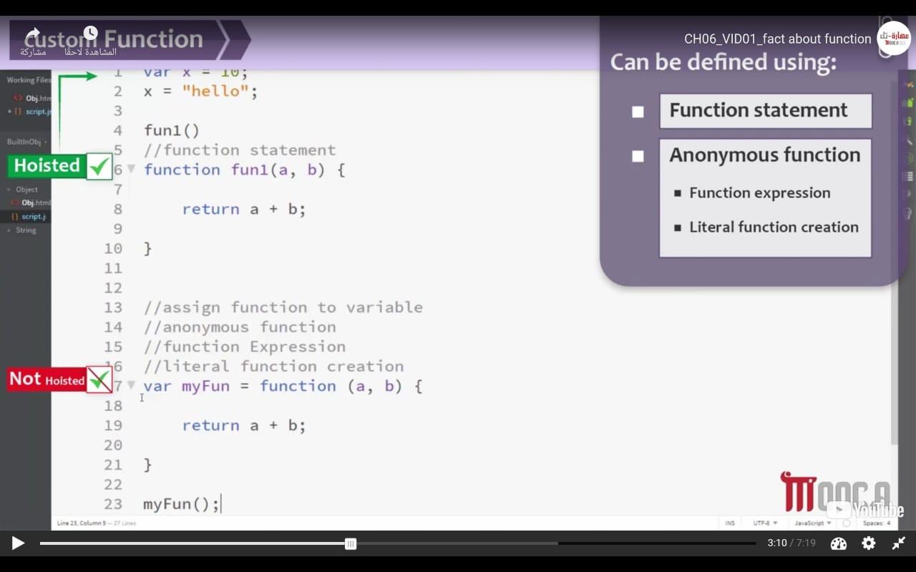
2. Assign fun into array element
   1. 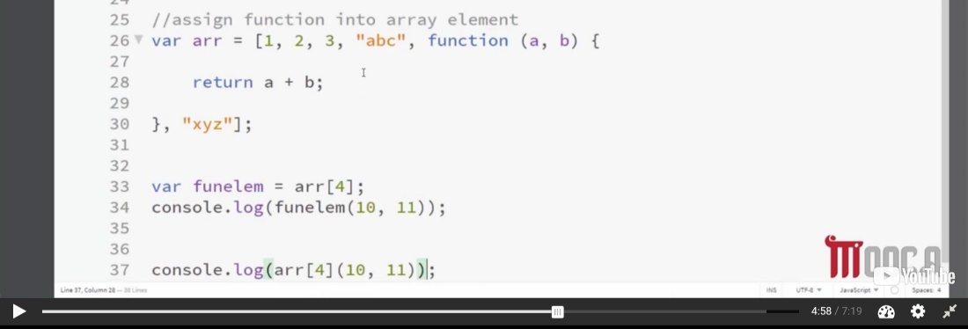
3. Return fun from another fun
   1. 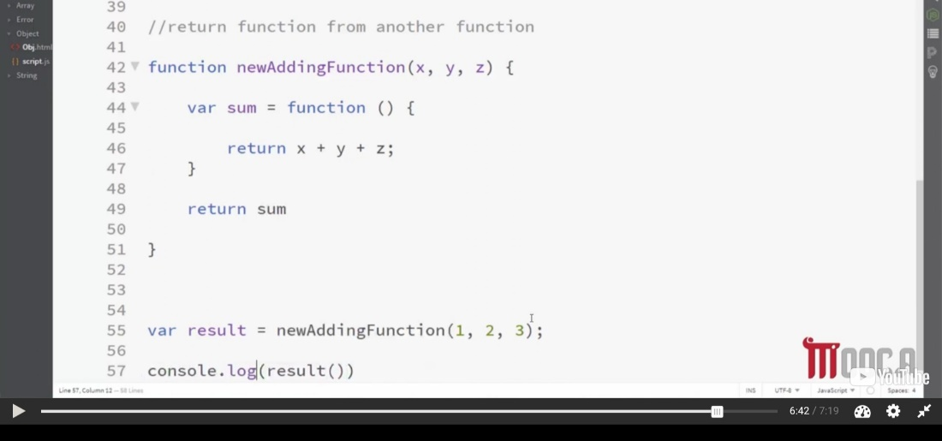

***Special Operators***

* Comma operators -> var first = “meroo” , last = “hassan”;
* Typeof -> Console.log(Typeof x);
* Ternary operator -> condition? Val1(if condition is true): val2(if condition is false)

***Communicating with the users -> Dialogue Box***

* Getting data from the user -> Prompt (return string even number)
* Giving the user a pop up message -> Alert
* Ask the user a simple “yes or no” type of question -> confirm

***Notes***

* F12
* <Script> inside body or head called internally
* Js parser -> translate code of js HTML parser -> translate code of HTML
* Conditional statement -> if ... else / switch
* Primitive data type ->
  + Undefined
  + null
  + Number
  + Boolean
  + String
* Operators ->
  + Binary operator
    - Arithmetic -> x + y each of called operand
    - Assignment operators -> += , *= , -= , /= , %=
    - Comparison operator -> < , > , =
    - Logical operators -> && , ||
      * && , || use of short circle -> ex -> in case of && if first condition is false so final value is false
  + Ternary operator
  + Unary operator
    - Increment / decrement -> prefix / postfix
    - Logical operators -> ! (not)
* False -> empty string, null, undefined, zero, false
* && -> 3 && 5 && 7 (output is 7) because && is searching for value of false
  + Ex -> 3 && 0 && 7 && 8 (output is 0)
* || -> 3 || 5 || 7 (output is 3) because || is searching for value of true
  + Ex -> 7 || 0 || 9 || 0(output is 7)
* ! -> !9 (false) , !!9(true)
* Coercion -> convert the number to string / convert the Boolean to number
  + Var x = 5; var y = “5”; console.log(x == y); // true
    - (علشان لقى قيمه الواى باسترينج فحول قيمه الاكس لاسترنج)
    - Solution
      * Strict equality -> ===
* 3<2<1
  + 3<2 is false -> false < 1 -> 0 < 1 //true
    - Convert the Boolean to number
    - Solution
      * 3< (2<1) // false
* Loop Statement
  + For() -> known the end
  + For(in) -> associative array
  + While()
  + Do while()
* Shadowing
  + Var z = 40 in global var z = 5 in local (in function) -> output of z = 40
    - even if print z after call function
* Hoisted

***Link***

* <script src = “ ”></script>

***Search***

API Authentication Cross Origin API [CROS]

***Note***

***Document.getElementById(“”).onclick = fun***

* ***() -> (لو الفانكشن بترجع حاجه يبقى احط الاقواس غير كده لا)***
* ***(علشان لو حطيت الاقواس والفانكشن مش بترجع فكده هترجع ديفاين***

***.(paramenter of function as event)preventDefault()***